ECEN 5833: Low Power Embedded Design Techniques

CUBIT

Smart Measuring Instrument

Team Name: Cubit

Team Members: Rajat Chaple

Saloni Shah

Contents

Project Proposal 5

1.1 Background 6

1.2 Project Summary 6

1.3 Product Application 7

1.4 Block Diagram 8

1.5 Product Components 8

1.6 Proposed Product Demo 10

1.7 Product Features 12

1.8 Product Specifications 12

2 Project Update 2 13

2.1 Activities accomplished in past week 14

2.2 Activities for the coming week 14

2.3 Energy model for the product: 15

2.4 Sensor selection: 16

2.4.1 IMU Sensor: BNO005 16

2.4.2 Rotary encoder 16

2.5 Program Flowchart: 17

3 Project Update 3 18

3.1 Activities accomplished in past week: 19

3.2 Activities for the coming week 20

3.2.1 Super Cap vs Battery 21

3.3 Power Management Unit Selection 22

3.3.1 Determining the required voltage range for the product 22

3.3.2 Determining the power management topology 23

3.3.3 Determining Regulated or Unregulated Power Source 23

4 Project Update 4 27

4.1 Activities accomplished in past week: 28

4.1.1 Change in the Power management strategy 28

4.1.2 Tested battery power consumption from a sample project 29

4.1.3 Version tracking using GitHub 31

4.1.4 Timing information 31

4.1.5 Calculations for PMIC IC 32

4.1.6 Battery specifications 32

4.1.7 High risk elements: 33

4.1.8 Project Schedule: 34

4.2 Activities planned for the upcoming week: 34

5 Project Update 5 35

5.1 Activities accomplished in past week: 36

5.1.1 LCD Bringup 36

5.1.2 PMIC Simulation and Bulk capacitance 39

5.2 Activities planned for the upcoming week: 40

5.3 Miscellaneous: 40

6 Project Update 6 48

6.1 Activities accomplished in past week: 49

6.1.1 IMU Bring-up 49

6.1.2 Magnetic Encoder Bring-up 51

6.1.3 Actual Bulk capacitor value required (considering the DC bias) 54

6.1.4 IO Ports in design 55

6.1.5 ESD protection 55

6.2 Activities planned for the upcoming week: 56

Tables:

Table 1: Components List 8

Table 2: Temperature specifications for sensors 12

Table 3: Super cap - Battery comparison 21

Table 4: Supercap and battery specifications 21

Table 5: Voltage range for components 22

Table 6: Components' library list 28

Table 7: Timing Information 31

Table 8: Battery specifications 32

Table 9: Battery Tolerances 32

Table 10: Project Schedule 34

# Project Proposal

ECEN 5833: Low Power Embedded Design Techniques

CUBIT

Smart Measuring Instrument

Team Name: Cubit

Team Members: Rajat Chaple

Saloni Shah

## Background

A measuring tape is used in a myriad of commercial businesses like construction, tailoring, warehouses as well as in day-to-day life. The first standard measuring tape was invented in 1850s and till now we have been using the same product. Although, since 18th century the world has advanced in every possible way, we still use the same measurement technique. The conventional measuring tape has ample of drawbacks like taking and maintaining measurements is very tedious, also all the measurements taken are majorly single use. It is high time that we modernize our method of taking measurements and digitize the data which can be easily stored and accessed from anywhere.

## Project Summary

For the course project, our team is designing a smart measuring instrument which will have the capability to take precise linear and angular measurements and transmit the data over to a mobile application using Bluetooth. Primarily, this device will have an encoder-wheel assembly which can be used to take measurements over a straight or curved surface very accurately. A high precision rotary encoder will be helpful in giving high resolution results. Moreover, we will also install an inertial measurement unit (IMU) sensor to take different angular and device orientation data. Both measurements can then be transmitted to a mobile app connected to the product using Bluetooth. This data will also be displayed on an LCD. This device will run on a small battery, and it will also contain an energy harvesting system using solar panel to recharge the battery. All these components will be interfaced with a single Blue Gecko board. The device will operate in low power mode by implementing load power management and utilizing minimum current for required peripherals.



cm

108

0

°



Measuring Tape



Wheel fixed on

rotary encoder



LCD

Figure 1: Product Concept

## Product Application

* This product can be used to fulfill majority of measurement requirements like taking size data of a straight or uneven surface and taking angle measurements.
* This product can be used in small industries, construction sites, fashion companies and regular households.
* This product will eliminate the need to manually store measured data.
* This product will be low cost, low power consuming with energy harvesting mechanism.
* This product will use long lasting rechargeable batteries unlike single usage dry cells.

## Block Diagram

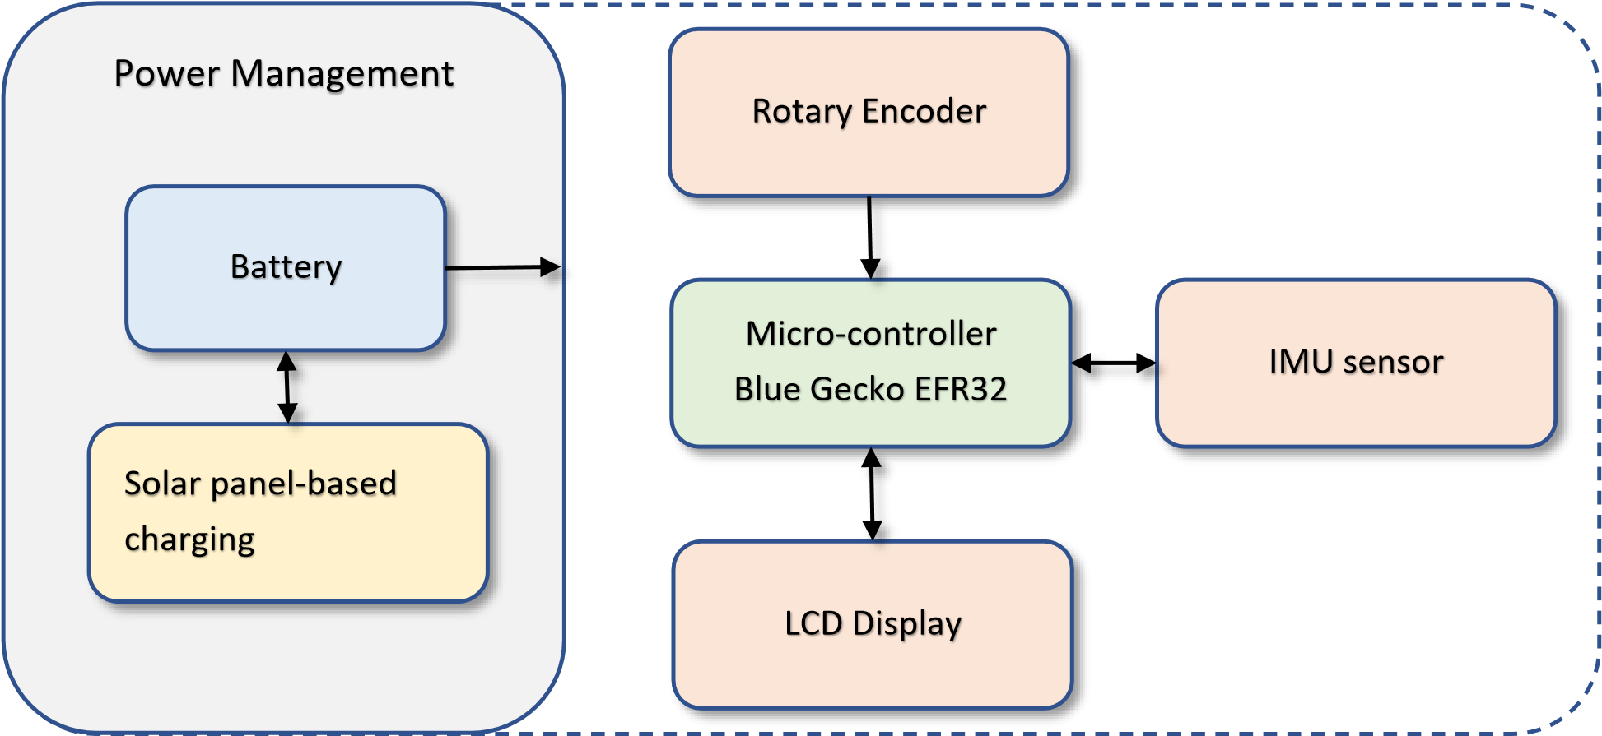

Figure 2: Block Diagram

## Product Components

Table 1: Components List

|  |  |  |  |
| --- | --- | --- | --- |
| Component |  | Part No. | Load Power Management |
| Microcontroller | Silicon Labs Blue Gecko |  |  |
| Radio | EFR32BG13 |  |  |
|  |  |  |  |
| Battery | Lithium Ion/Lithium Polymer | [LP802036JU+PCM+2 WIRES](https://www.digikey.com/en/products/detail/jauch-quartz/LP802036JU-PCM-2-WIRES-50MM/9560981)  [50MM Jauch Quartz | Batte](https://www.digikey.com/en/products/detail/jauch-quartz/LP802036JU-PCM-2-WIRES-50MM/9560981)  [Products | DigiKey](https://www.digikey.com/en/products/detail/jauch-quartz/LP802036JU-PCM-2-WIRES-50MM/9560981) |  |
| PMIC | BQ25570 | [BQ25570RGRT Texas](https://www.digikey.com/en/products/detail/texas-instruments/BQ25570RGRT/4430477)  [Instruments | Integrated](https://www.digikey.com/en/products/detail/texas-instruments/BQ25570RGRT/4430477)  [Circuits (ICs) | DigiKey](https://www.digikey.com/en/products/detail/texas-instruments/BQ25570RGRT/4430477) |  |
| Buck Converter | TPS62842  Or PMIC internal buck converter | [TPS62842DGRR Texas](https://www.digikey.com/en/products/detail/texas-instruments/TPS62842DGRR/12352343?s=N4IgTCBcDaIC4AcDOA2MAOALBAugXyA)  [Instruments | Integrated](https://www.digikey.com/en/products/detail/texas-instruments/TPS62842DGRR/12352343?s=N4IgTCBcDaIC4AcDOA2MAOALBAugXyA)  [Circuits (ICs) | DigiKey](https://www.digikey.com/en/products/detail/texas-instruments/TPS62842DGRR/12352343?s=N4IgTCBcDaIC4AcDOA2MAOALBAugXyA) |  |
| Sensor | IMU sensor | BNO005 (To be acquired from Professor) |  |
|  | Rotary Encoder | [Magnetic Rotary](https://www.digikey.com/en/products/detail/ams/AS5147P-TS-EK-AB/5452349)  [Encoder](https://www.digikey.com/en/products/detail/ams/AS5147P-TS-EK-AB/5452349)  [Magnetic Wheel](https://www.digikey.com/en/products/detail/ams/RMH05-DK-XX-1-0/3712276)  [Assembly](https://www.digikey.com/en/products/detail/ams/RMH05-DK-XX-1-0/3712276) |  |
|  | Ultrasonic Sensor | [Adafruit Ultrasonic Sensor](https://www.digikey.com/en/products/detail/982/982-ND/5356850?itemSeq=389285645) |  |
| HMI | LCD Display | [Adafruit SHARP](https://www.adafruit.com/product/3502)  [Memory Display](https://www.adafruit.com/product/3502)  [Breakout - 1.3"](https://www.adafruit.com/product/3502)  (Acquired from  Professor) |  |
|  | Push Buttons | Available |  |
| Energy Harvesting System | Solar cells | [Monocrystalline solar cells](https://www.digikey.com/en/products/detail/anysolar-ltd/KXOB25-12X1F-TB/9990434) |  |

## Proposed Product Demo



0

c

m

0

°



Measuring Tape



cm

36

0

°



Measuring Tape



108

cm

0

°



Measuring Tape

Figure 3: Proposed Product Demo 1

As shown in the above image, this measuring tape can be used to measure any surface. The wheel encoder assembly installed on the product can be slid over a flat or uneven surface to get size value accurately. This measuring tape will have a high resolution in centimeter because of the use of a precision Rotary encoder with large number of pulse detection in a single rotation.



108

cm

0

°



Measuring Tape

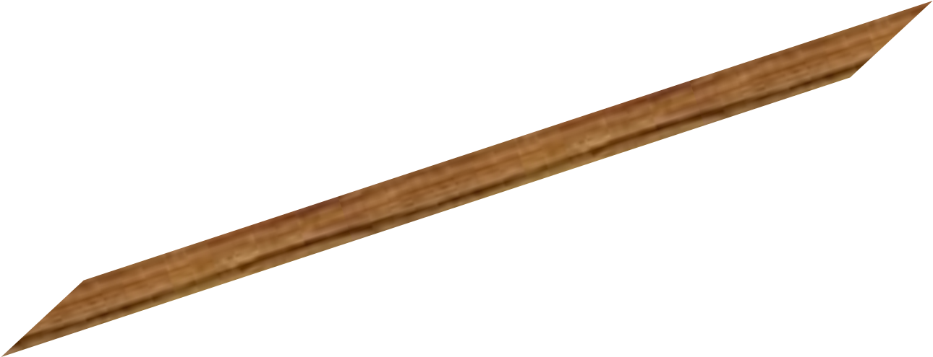

Figure 4: Proposed Product Demo 2

The above image shows how an angle measurement can be carried out using the product. This angle can be measured in any orientation of the device. The angle measurement will also be highly accurate due to the IMU sensor.

## Product Features

* Free android app to store and manage measurement data
* Bluetooth connectivity of mobile phone with the device
* Rotary encoder-wheel assembly for linear measurement
* IMU sensor for accurate angle measurement
* LCD Display for better user experience
* Energy harvesting mechanism using solar panels
* Load power management by turning on only required peripherals
* Single rechargeable LiPo battery which can power the complete device

## Product Specifications

* Dimensions: 100mm x 70mm
* Weight: 100g
* Wireless range: 100 m
* Size accuracy: ± 1 cm
* Angle accuracy: ± 1°
* Product Warranty: 2 years
* Operating Temperature: 0°C - 65°C
* Internal sensors and peripheral operating temperature:

Table 2: Temperature specifications for sensors

|  |  |
| --- | --- |
| Sensor | Operating Temperature Constraints |
| Blue Gecko | -40 to 85 °C |
| IMU | -40 to 85 °C |
| Rotary encoder | -40 to 150 °C |
| LCD Display | -40 to 70 °C |

# Project Update 2

ECEN 5833: Low Power Embedded Design Techniques

CUBIT

Smart Measuring Instrument

Team Name: Cubit

Team Members: Rajat Chaple

Saloni Shah

Date: 01/29/2022

## Activities accomplished in past week

* Studied mouse scroll-wheel encoder assemblies to decide the decide the mechanical assembly for final product. Disassembled 4 different optical mouses to explore different assemblies.

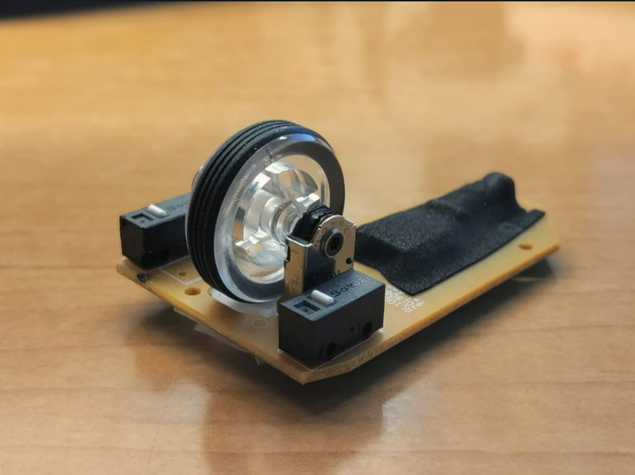

Figure 5: Scroll wheel encoder assembly

* Measured PPR(Pulse per rotation) of rotary encoder and circumference of wheel to estimate linear measurement resolution. o Finalized ultra-low power Graphic LCD display. o Estimated total power and energy consumption of the product.
* Worked on project planning and estimated timeline.

## Activities for the coming week

* Finalize battery and solar panel based on energy consumption requirements. o Finalize Power management IC.
* Work on power supply circuit for the product.

## Energy model for the product:

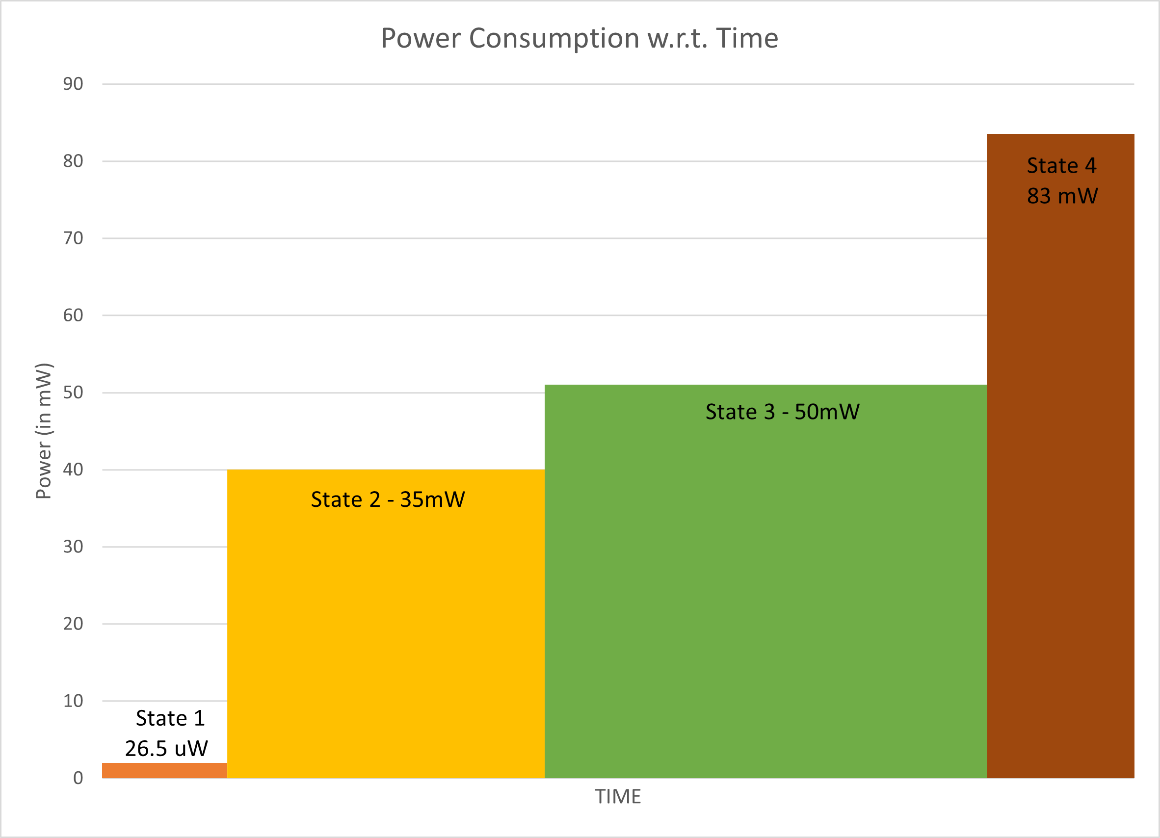

Figure 6: Energy model

## Sensor selection:

### **IMU Sensor: BNO005**

* + - This sensor works on I2C as well as UART.
    - We will be interfacing the sensor using I2C as data transfer over UART communication takes longer and even though it consumes less energy, overall efficiency of UART decreases. Moreover, for transfer of larger data bytes I2C consumes the same amount of energy. (These assumptions were made using [this reference.](http://cc.oulu.fi/%7Ekmikhayl/site-assets/pdfs/2012_NTMS.pdf))
    - This sensor will require external load switch as after start-up it only enters low power mode and suspend mode. (Even in suspend mode it consumes 40uA of current).

### **Rotary encoder**

* + - This mechanical encoder has just 2 digital pins which can be wired directly as input to the controller. The encoder generated pulses gives the angular position of the axis and can then be converted to digital output.
    - The encoder will also require external load switch as it does not have internal circuitry to turn power off.

[Online Project Management using Monday.com](https://view.monday.com/2210043877-dee7e4668b7b619c0c4a18486899a087?r=use1)

## Program Flowchart:

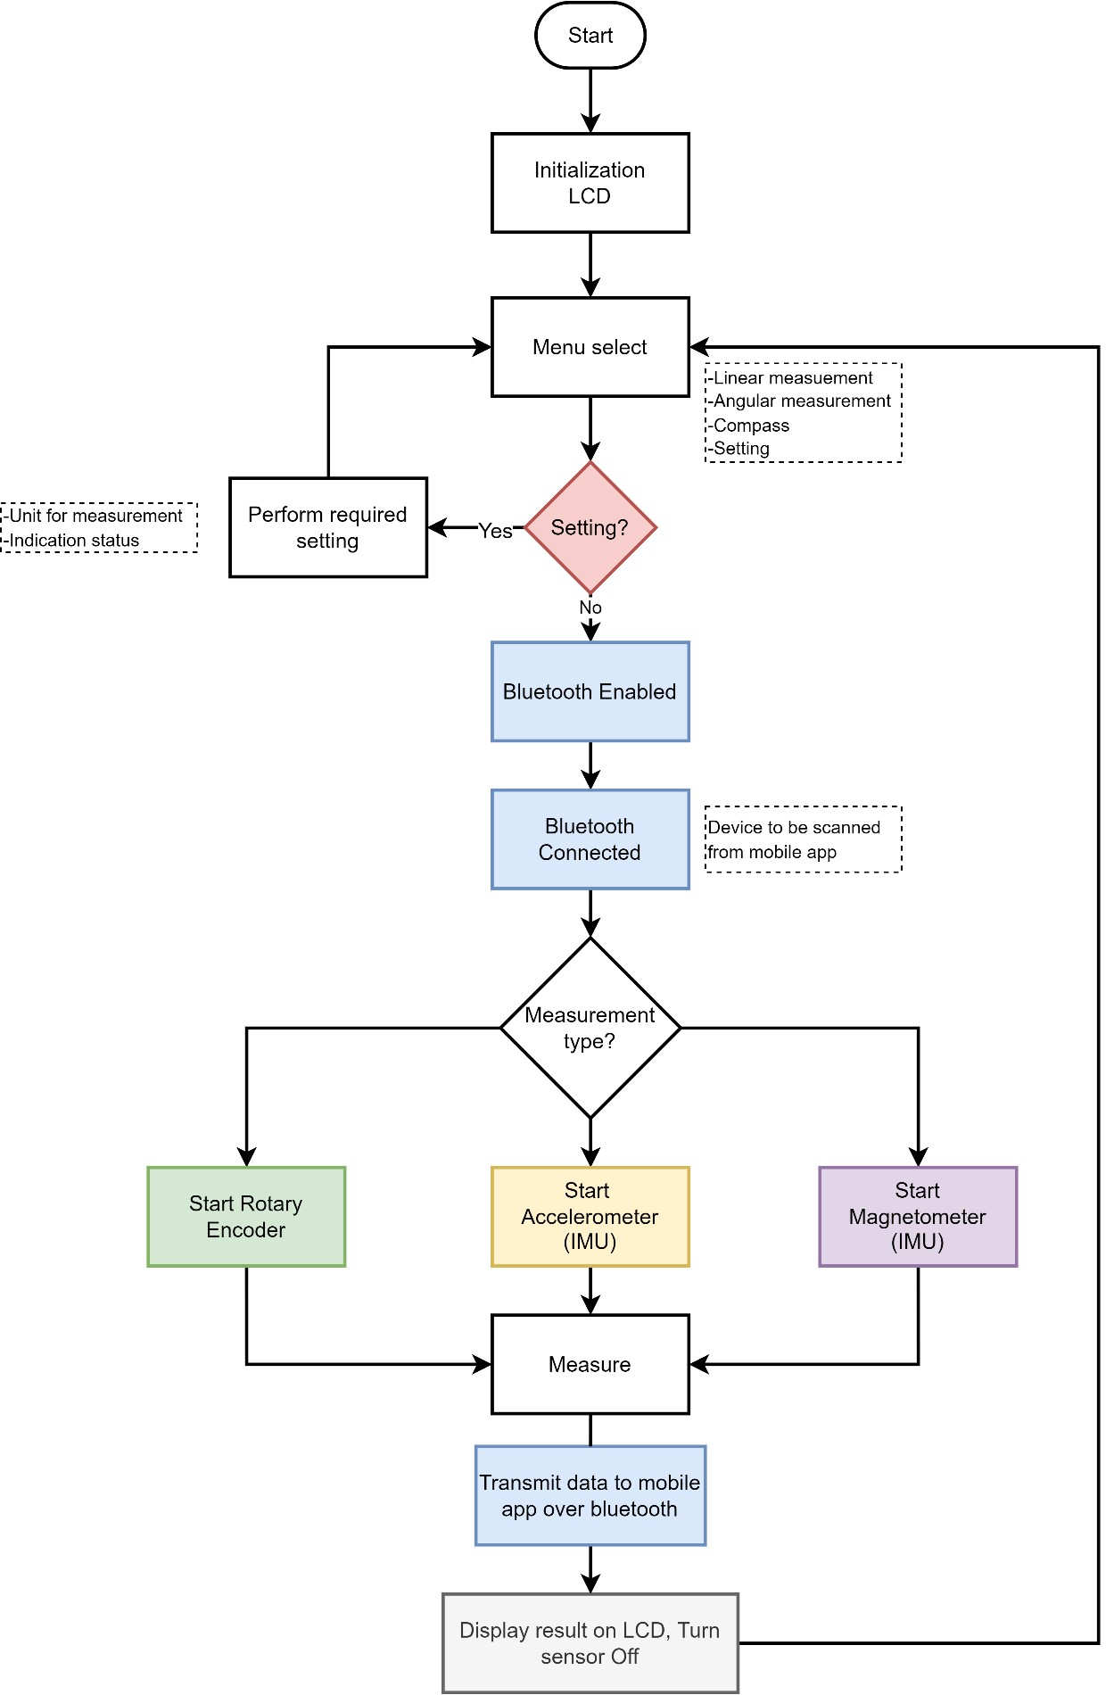

Figure 7: Flowchart

# Project Update 3

ECEN 5833: Low Power Embedded Design Techniques

CUBIT

Smart Measuring Instrument

Team Name: Cubit

Team Members: Rajat Chaple

Saloni Shah

Date: 02/05/2022

## Activities accomplished in past week:

* Finalized energy storage element (battery) based on energy consumption requirements.
* Finalized Power management IC and buck-converter IC.
* Practically implemented measurement system using mechanical rotary encoder, string-pulley assembly and interfaced it with Arduino. Found out that the rotary encoders have a limitation on how fast it can detect rotations i.e. it can only detect signals correctly at less than 160 rpm.

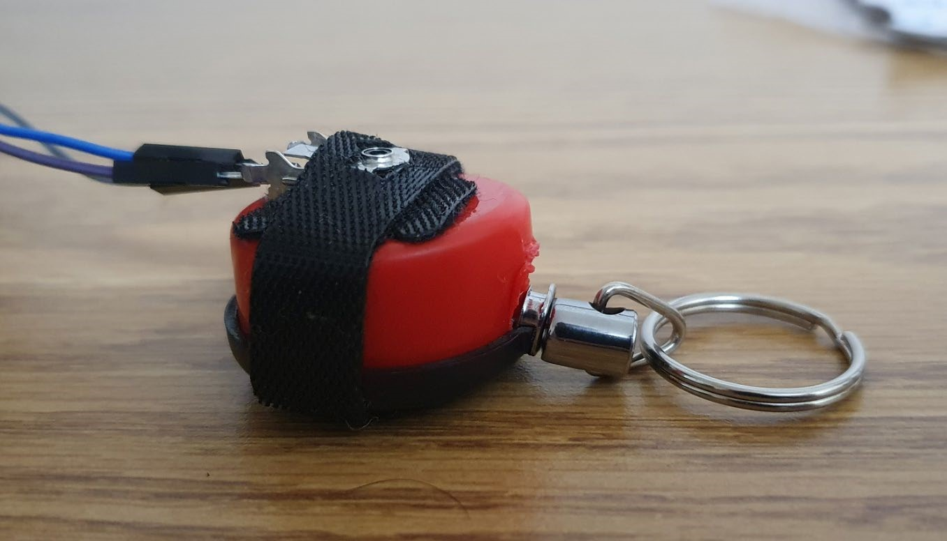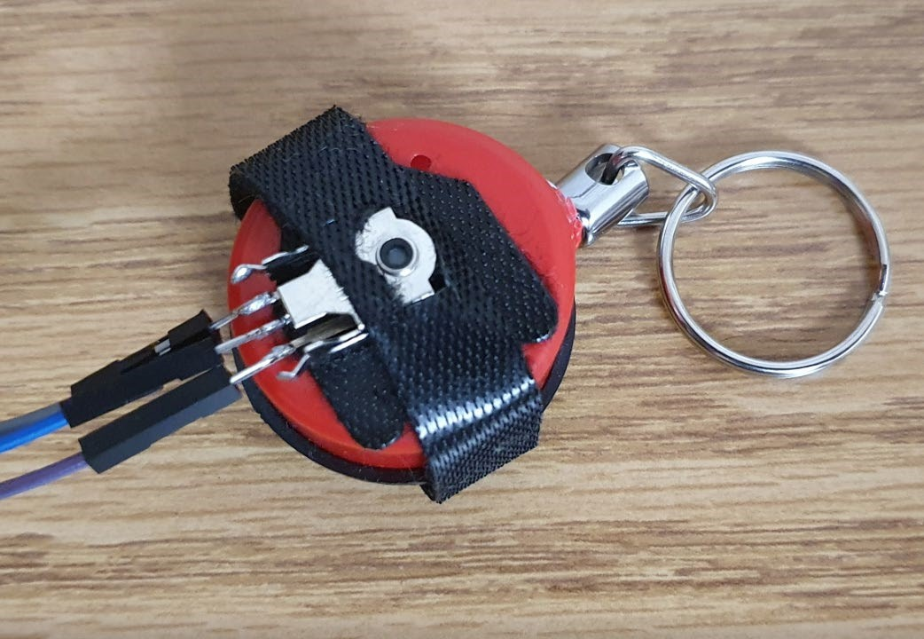

Figure 8: Assembled rotary encoder with a string-pulley

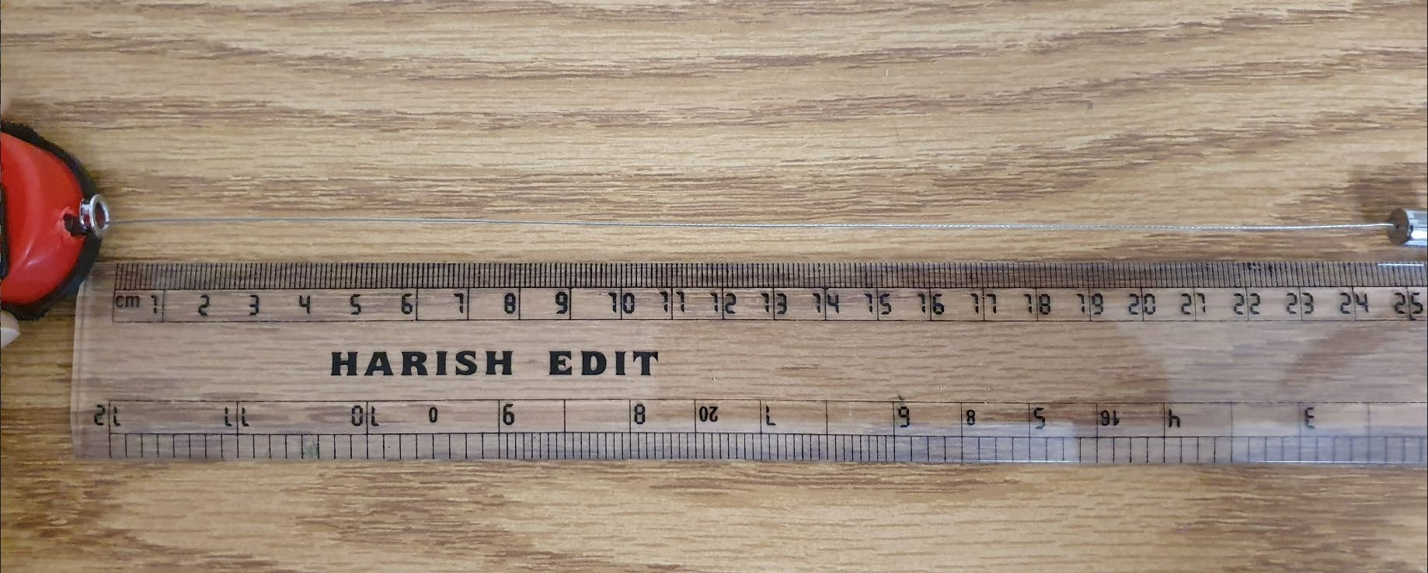

Figure 9: Measuring the length of a ruler using the assembly

Arduino serial monitor output with number of pulse counts and calculated length

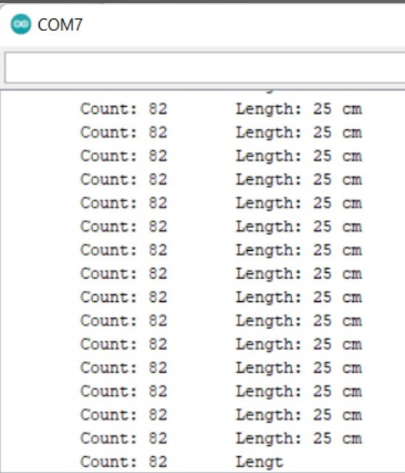

Figure 10: Optical Rotary Encoder output

* Changed the required rotary encoder from mechanical to magnetic due to speed constraints and higher chances of signal misses in the mechanical encoder.
* Finalized required magnetic rotary encoder and ultrasonic sensor for measurement applications.

## Activities for the coming week

* Finalized energy harvesting element (solar panel) based on energy consumption requirements.
* Design product power supply circuit.
* Interface LCD display with Blue Gecko Evaluation Module.
* Finalize other required components for the product schematic design.

Power Storage Element Selection

o Expected runtime using supercapacitor = 1.36 hours

o Expected runtime using battery = 3 days (8 hours per day)1

### **Super Cap vs Battery**

Required peak current: 25 mA

Average current consumption: 13.68 mA

Average Charge requirement for continuous 8 hours operation: 110mAh

Average Energy Required for 8 hours of operation: 328.4 uWh

Ambient Temperature Conditions: Room Temperature (about 25° C)

Table 3: Super cap - Battery comparison

|  |  |
| --- | --- |
| **Super Cap** | **Battery** |
| Steep discharge curve | Higher operating time |
| Large leakage current (30 uA) | Very less leakage current (2%/year) |
| Cannot handle required peak current | Can handle upto 1A peak current |
| Lower energy density | Higher energy density |
| Can operate in very low temperature | Dispenses less energy in low temperatures |
| Lower ESR power loss | Higher ESR power loss |

Table 4: Supercap and battery specifications

|  |  |  |
| --- | --- | --- |
| **Design Requirements** | **Super Cap (Tecate 100F)** | **Battery (Jauch 480mAh)** |
| Useable Energy | 234.5J2 - 18.6mAh | 480 mAh |
| Peak Discharge Current |  | 1A |
| Recharge time |  | 2 hours @ 0.5C |
| 2 years of use, 300 charges | 500,000 cycles | 300 cycles ~ 80% capacity usage |
| Leakage current or rate | 3 uA | Less than 2-3% |
| ESR | 210 mΩ |  |
| Mechanical Dimensions | 12.5 x 25 mm | 38 x 20.5 mm |

1. Refer attached spreadsheet for calculations
2. Refer attached spreadsheet

## Power Management Unit Selection

### **Determining the required voltage range for the product**

o To decide the operating voltage range for the product, we looked at the input voltage range of the peripherals utilized in the system. The below table shows the minimum and maximum input voltage range of the sensors and MCU.

Table 5: Voltage range for components[1]

|  |  |  |  |
| --- | --- | --- | --- |
| Sensor | Vin(min) | Vin(max) | Current Consumption |
| Blue Gecko | 1.8V | 3.8V | 4uA |
| IMU | 2.4V | 3.6V | 12.3mA |
| Rotary encoder | 3V | 3.6V | 15mA |
| LCD Display | 3V | 5V | 4uA |

* + - * Based on the above calculations, we decided to operate all the peripherals at 3.0V as to utilize maximum possible battery capacity and increase the operating time of the system.
      * The approximate range of the supply voltage will be from 3.0-3.6V.

### **Determining the power management topology**

* Considering that the power source battery gives maximum 3.7V and our required voltage supply for the peripherals is about 3.0V, which is always lower than supply voltage we decided to implement a buck converter to meet our power requirements.
  + - The primary reason for choosing a buck converter as opposed to a buck-boost is that most Lithium-Poly batteries have a plateau from 3.5-3.6V

and very little charge below this plateau, limiting the usefulness of the buck-boost converter and its wide input voltage range[2].

* + - * Moreover, the buck-boost converter also has one additional MOSFET as compared to the buck converter which increases power loss and decreases efficiency of the converter.
      * Keeping this in mind, we searched for a buck converter IC, with high efficiency, low quiescent current, low cost, and smaller footprint.
      * All these requirements were successfully met by the buck converter TPS62840[3].

### **Determining Regulated or Unregulated Power Source**

* + - While deciding whether to use regulated or unregulated power source, we carried out following calculations to understand efficiency of both topologies.

Assumed product usage of 60 minutes or 3600 seconds

Assumed number of measurements in 1 hour, average of 20 measurements

Assumed period for one measurement, average of 13 seconds

On duty cycle = (20 measurements * 13 seconds) / 3600 = 7.2% Off duty cycle = 92.8%

TPS62840 Buck converter Efficiency Curve

* + - Off duty cycle = 0.015-0.020 mA

Estimated 87.5% efficiency

* + - On duty cycle = 15-20 mA range

Estimated 94% efficiency

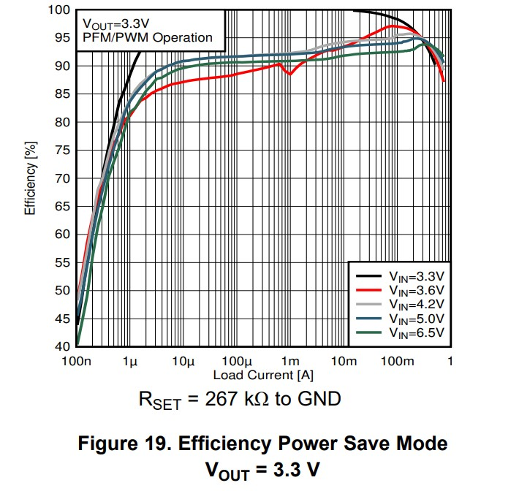

For regulated power case (using TPS62840 buck converter):

* + - On duty cycle
    - TPS62840 efficiency ~3.6V input and 15,500uA is 94% + 0.06uA Iccq
    - Weighted avg power OOB = (On duty cycle * (15500 + 0.06) * 3.0V) / 94%
    - Weighted average power out of battery = 3561 uW o Off duty cycle
    - TPS62840 efficiency ~3.6V input and 20uA is 87.5% + 0.06uA Iccq
    - Weighted avg power OOB = (Off duty cycle * (20 + 0.06) * 3.0V) / 87.5%
    - Weighted average power out of battery = 63.8 uW o Total Average Power out
    - Weighted on duty cycle average power + Weighted off duty cycle average power = 3561uW + 63.8uW = 3624.825 uW

For unregulated power case (using Blue Gecko internal LDO):

* On duty cycle
  + - Gecko efficiency ~3.6V input and 15,500uA is 83.33%
    - Weighted average power OOB = (On duty cycle * 15500 * 3.0V) / 83.33%
    - Weighted average power out of battery = 4017.7 uW o Off duty cycle
    - Gecko efficiency ~3.6V input and 20uA is 83.33%
    - Weighted average power OOB = (Off duty cycle * 20 * 3.0V) / 83.33%
    - Weighted average power out of battery = 66.81 uW o Total Average Power out
    - Weighted on duty cycle average power + Weighted off duty cycle average power = 4017.7uW + 66.81uW = 4084.5 uW

Increase in battery life using regulated power = 1 - 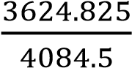

= 11.25%

Based on above calculations, we decided to use a regulated power source since it provides longer battery life. Moreover, we have a higher on duty cycle, higher power on to power off ratio, higher efficiency at light load and low quiescent current which justifies the use of regulated power source.

**3.4. Determining the Power Management IC**

o The primary criteria for selecting a PMIC were low minimum input voltage limit to support very low voltage from energy harvesting element (solar cell) and efficient boost converter. A simple and efficient circuitry for energy harvester is required which were available in PMIC BQ25570.

* The input voltage supported in this IC is 0.1-5.1V. Also, many typical solar cells have an output voltage of 0.1V.
* Another important criterion is to have a wide range of input voltage from battery to support lower battery power which is 2-5.5V in case of BQ25570.
* This IC also has higher charging current capacity (maximum 285mA) for fast charging from external charger or a USB charging port.
* BQ25570 also has internal Programmable Maximum Power Point Tracking (MPPT) circuitry for optimal energy extraction from energy harvester like solar panel.
* Moreover, BQ25570 has internal boost as well as buck converter to boost low input voltage from the energy harvester and simultaneously regulate the output voltage[4].

# Project Update 4

ECEN 5833: Low Power Embedded Design Techniques

CUBIT

Smart Measuring Instrument

Team Name: Cubit

Team Members: Rajat Chaple

Saloni Shah

Date: 02/12/2022

## Activities accomplished in past week:

* Generated Altium components library for following parts

Table 6: Components' library list

|  |  |  |  |  |
| --- | --- | --- | --- | --- |
| **Sr. No** | **Part Description** | **Part Number** | **Footprint Name** | **Online SnapEDA/ Octopart Link** |
| 1 | Blue Gecko | EFR32BG13P732F512GM48-D | 48-QFN_7x7 | N/A |
| 2 | PMIC | BQ25570RGRT | 21_QFN_35X35 | N/A |
| 3 | IMU Sensor | BNO055 | LGA28R50P4X10_380X520X100 | [BNO055 SnapEDA](https://www.snapeda.com/parts/BNO055/Bosch%20Sensortec/view-part/) |
| 4 | Magnetic Encoder | AS5147P-HTSM | 14-TSOP_5x4_4 | N/A |
| 5 | Resistor | RMCF0603FT1K00 | 2_Chip_0603_RMCF | N/A |
| 6 | Capacitor | CL10A475KP8NNNC | CAP_0603_1MM | N/A |
| 7 | Inductor | VLS3015CX-220M-1 | 2_IND_3x3 | N/A |
| 8 | LED (red) | 150060RS75000 | LED_0603_RED_WL-SMCW | N/A |
| 9 | LCD header | 3502 | LCD_SHARP_MEMORY_9_PIN | N/A |

### **Change in the Power management strategy**

* + With earlier update, plan was to use PMIC bq25570 and TPS62842 buck converter. Criterion for selection of external buck converter instead of one already integrated into bq25570 was Efficiency. However, considering ON duty cycle of the product operation, efficiency would no longer be a preliminary factor under consideration.
  + Also, major concern where we cannot utilize most energy from the battery was resolved using following.
    - Entire circuit would work at 3.15v
    - Buck converters have dropout voltage. This limits battery’s minimum usable voltage. As per datasheet, dropout voltage is maximum output current times the buck high side resistance.

Calculations:

Maximum output current: 35 mA

Maximum buck high side resistance: 200Ω

Dropout voltage: 35 x 200 = 0.7v

* + - Usable battery would be in the range of 3.7v down to 3.22v.

### **Tested battery power consumption from a sample project**

* + As a case study one of the sample projects was arranged. Though this project’s objective is entirely different than that of CUBIT, similarities in functional blocks were identified. This project also contains solar energy harvesting, PMIC and a load.

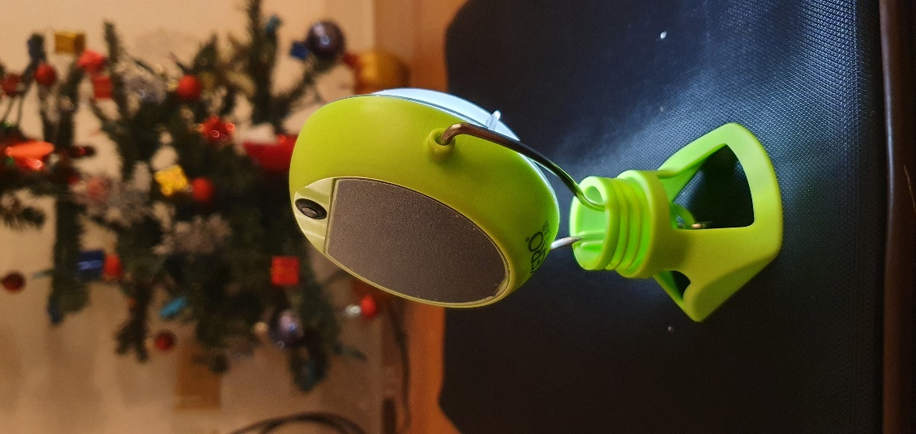

Energy Harvesting unit

Load  
(Power LED)

Battery

(300 mAh)

Figure 11: Sample Product for case study

*Calculations:*

*Continuous current consumption by Power LED = 55 mA*

$$Theoretical battery backup=\frac{Battery capacity\left(mAh\right)}{Continuous current consumption}$$

$$=\frac{500}{55}=9.09 Hrs$$

Objective: Solar power lamp

Battery capacity = 500mAh

No of Solar cells = 7 (part number unknown)

LEDs: 1 power LED of typical current consumption of 50mA

Solar Panel

Microcontroller

LED Driver

LED

Battery

Sample Project Block Diagram

Practically measured battery backup: 9 hours

If current consumption was 18mA, we would get battery backup of ~27 Hrs

Outcome of the experiment:

Our calculation for CUBIT falls between this range where battery backup for 480 mh battery with 18mA avg current consumption is around 24 Hrs. This verifies calculations against practical measurements.

* + Finalized solar cell unit

Calculations:

As per calculations in spreadsheet bq25570SolarAppDesign.xlsx,

Minimum solar panel area required is 8mW/cm2

As per datasheet: [solar cell](https://waf-e.dubudisk.com/anysolar.dubuplus.com/techsupport@anysolar.biz/O18Adzn/DubuDisk/www/Gen2/KXOB25-12X1F%20DATA%20SHEET%20202007.pdf) (2994-KXOB25-12X1F-TB-ND), maximum peak power is 24.5mW per 1.54 cm2

This implies power/cm2

Selected component satisfies this requirement of minimum 8mW/cm2

### **Version tracking using GitHub**

Updated previous updates, libraries and calculation documents to github

[rajatchaple/ecen5833_s22_lpedt_project (github.com)](https://github.com/rajatchaple/ecen5833_s22_lpedt_project)

### **Timing information**

Following are the critical timing parameters per module.

Table 7: Timing Information

|  |  |  |  |  |
| --- | --- | --- | --- | --- |
| Device | Parameter | Description | Min | Max |
| AS5147 (SPI) | tL | Time between CSn falling edge and CLK rising edge | 350 ns |  |
| tH | Time between last falling edge of CLK and rising edge of CSn | 50 ns |  |
| tMOSI | Data input valid to falling clock edge |  |  |
| BNO055 | fSCL | Clock frequency |  | 400kHz |
| fSUDAT | SDA Setup Time | 0.1 us |  |
| HDDAT | SDA Hold TIme | 0 us |  |
| SHARP Memory LCD | fSCLK | Clock Frequency |  | 1.1MHz |
| tsSCS | SCS Setup time | 6 us |  |
| thSCS | SCS hold time | 2 us |  |
| tsSI | SI setup time | 250 ns |  |
|  | thSI | SI hold time | 350 ns |  |

### **Calculations for PMIC IC**

* Studied reference design in [bq25570 user guide](https://www.ti.com/lit/ug/sluuaa7a/sluuaa7a.pdf?ts=1644694996855&ref_url=https%253A%252F%252Fwww.ti.com%252Fproduct%252FBQ25570) in order to understand PMIC circuitry for our application.
* Also, used calculator provided by TI on [BQ25570 data sheet, product information and support | TI.com](https://www.ti.com/product/BQ25570#design-tools-simulation) to calculate Resistor values.

### **Battery specifications**

Table 8: Battery specifications

|  |  |
| --- | --- |
| **Parameter** | **Value** |
| Battery nominal Voltage | 3.7V |
| Typical capacity | 500mAh |
| Minimum capacity | 480mAh |
| Charge voltage | 4.2V |
| Standard current | 0.2C-100 mA |
| Max charging current | 0.5C – 250mA |
| Cut-off voltage | 3V |
| Max discharging current | 2C-1A |
| Power rating | 1.78Wh |

**Battery Tolerances**

Table 9: Battery Tolerances

|  |  |
| --- | --- |
| Parameter | Value |
| Overcharge voltage | 4.28 V ± 0.025 V |
| Overdischarge voltage | 3.00 V ± 0.05 V |
| Over current range | 1.0A to 4.0A |
| Charging operating temperature | +10°C to +45°C |
| Discharging operating temperature | -20°C to +25°C |

### **High risk elements:**

* Magnetic interference of two sensors
  + IMU has a magnetometer which is to be used for compass and the rotary encoder is also based on magnetic pulse. These two components can interfere with each other and show incorrect reading. As a measure to mitigate this risk, we will be placing the two components physically as far as possible from each other on the board.
* EMI interference
  + Similar to the issue mentioned, the magnetic field from these components can also generate electromagnetic interference which can disrupt the functionality of other components on the board especially inverted F-antenna for Bluetooth connection (radio frequency can be disrupted due to electromagnetic interference). The potential solutions to overcome EMI are filtering, shielding, or grounding.
* Dual charging system (USB and Solar cell)
  + As a power storage component, we are using a rechargeable LiPo battery. To recharge this battery, we are planning on using energy harvesting component - solar cells. Apart from the solar cells, we also intend to have a 5V USB charging port on the board.
  + The major drawback in this design is the unavailability of a power management IC to efficiently switch between solar cells and USB port. Even if we interface a USB port, we have to have a circuit design such that reverse current does not flow from battery to our energy harvesting device and also to automatically switch between solar energy and USB input.
  + In this circuit design, we plan to use Schottky diodes for fast switching and low voltage drop. In case we are unable to successfully implement this design, we will be eliminating use of USB charging port and use the solar power as our primary recharge source.

### **Project Schedule:**

Table 10: Project Schedule

|  |  |
| --- | --- |
| Task | Deadline |
| Altium Components Libraries | Feb 12, 2022 |
| Altium Product Schematic | Feb 26, 2022 |
| Altium Product Layout | March 5, 2022 |
| Product Final Layout for Fabrication | March 12, 2022 |
| Send PCCB board for fabrication | March 19, 2022 |

We are aligned with our project timelines except the task where our plan was to bring up LCD module last week. We will be achieving this task in upcoming week. Instead, this week we focused on our case study of sample project to verify our energy calculations.

## Activities planned for the upcoming week:

* Finalizing Bulk capacitance
* Implement LCD driver
* Schematic of Power Management Unit

# Project Update 5

ECEN 5833: Low Power Embedded Design Techniques

CUBIT

Smart Measuring Instrument

Team Name: Cubit

Team Members: Saloni Shah

Rajat Chaple

Date: 02/18/2022

## Activities accomplished in past week:

### **LCD Bringup**

* + LCD Interfacing with ESP8266
    - For quick test, LCD was interfaced with ESP 8266 using SPI protocol
    - Demo code was run from [Arduino Programming | Adafruit Sharp Memory Display Breakout | Adafruit Learning System](https://learn.adafruit.com/adafruit-sharp-memory-display-breakout/programming)

ESP 8266

3V3

GND

SCK

MOSI

CS

3V3

GND

D4

D7

D5

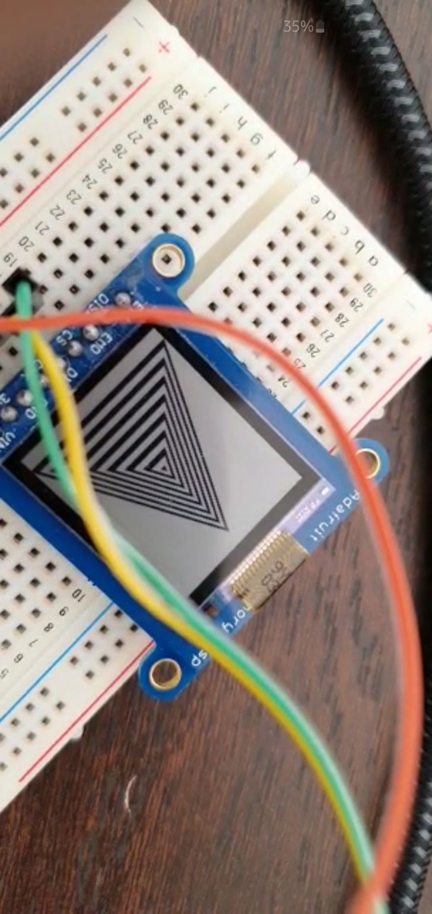

Figure 12 LCD Interfacing with ESP8266

* + LCD Interfacing with Blue Gecko
    - Connections

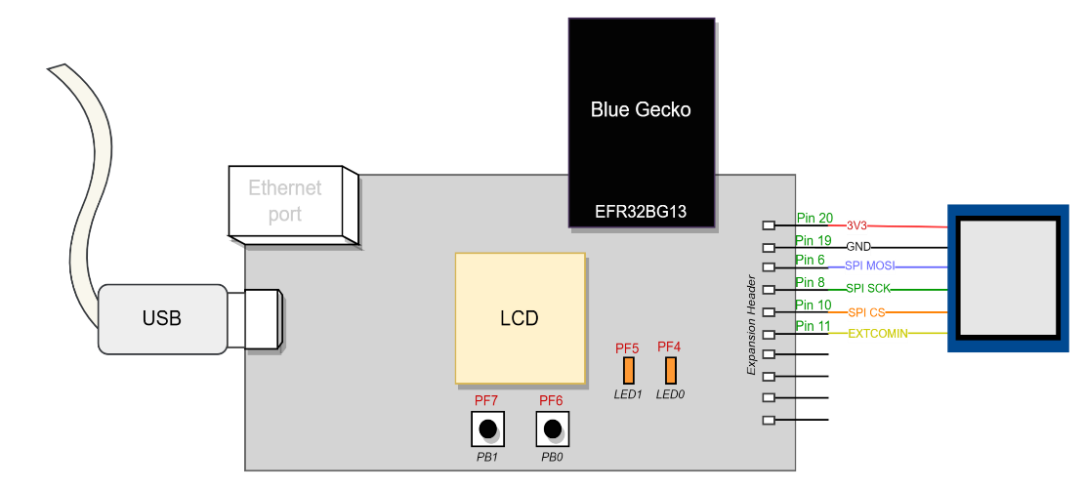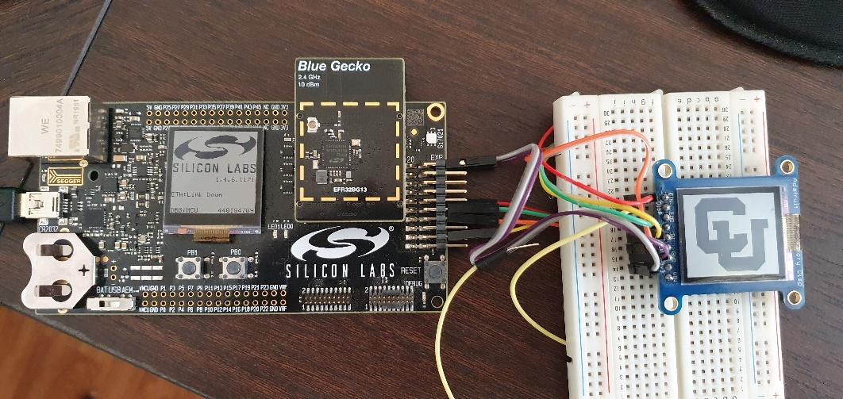

Figure 13 LCD Interfacing with Blue Gecko

* + - Python Script for Image to binary
      * LCD requires array in binary format representing the graphics
      * Python script was written to convert any image into 168x144 graphics.
      * CU Logo was generated using this script.
  + Findings

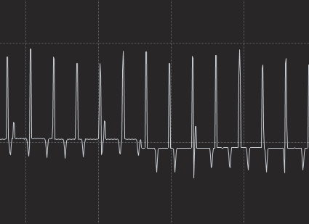

LCD connected:

Current (240 uA)

LCD detached:

Current (141 uA)

Figure 14 Current consumption by LCD

* + - Current consumed by LCD is around 100uA
  + Getting rid of additional components from the module

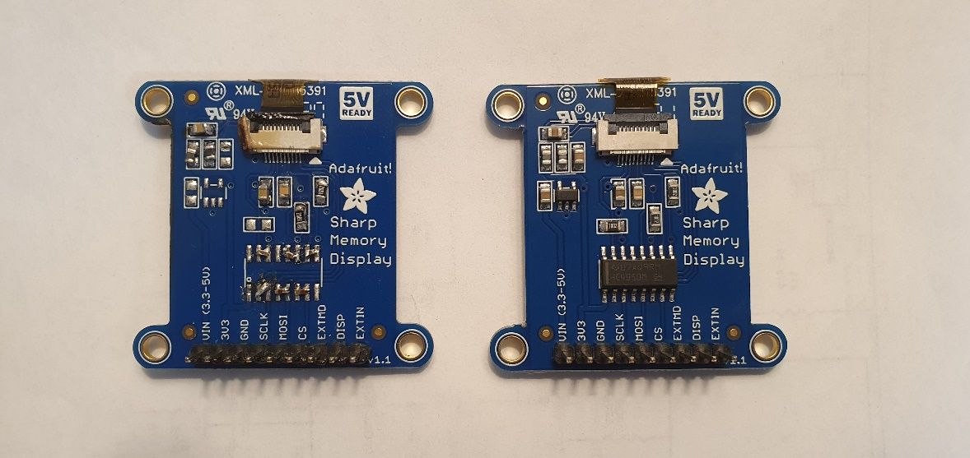

Removed Regulator and Logic level shifter

Figure 15 LCD without a breakout module circuit

Current consumption did not change even after removing these additional components

### **PMIC Simulation and Bulk capacitance**

* In order to simulate Power management unit in LTSpice, we did not find the exact part number
* Combination of boost circuitry and LT8604 was used to simulate as these parts were matching with bq25570 specs.

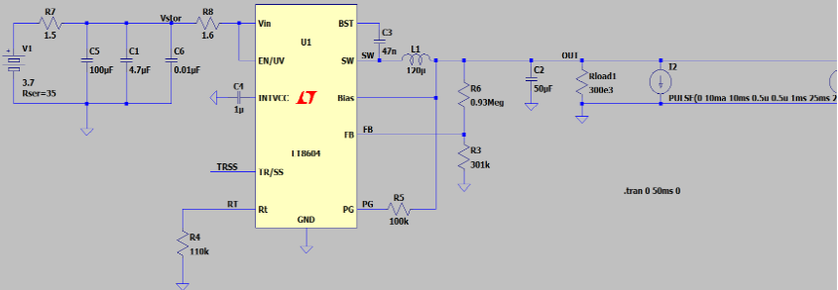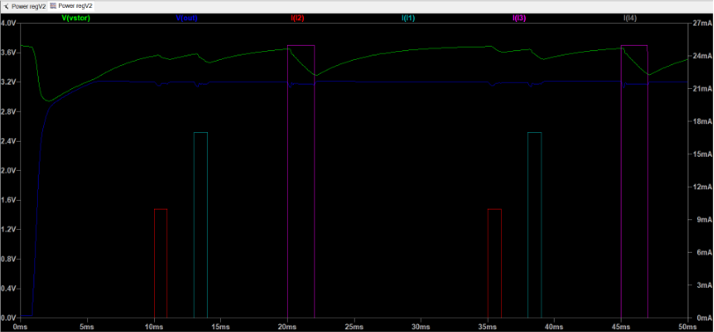

*Below simulation showed that there is need of 100uF bulk capacitor.*

*Addition of bulk capacitor restricts minimum voltage of the system at 3.15v. This satisfies requirements for all peripherals and the controller.*

Figure 16 Calculating Bulk capacitor value

## Activities planned for the upcoming week:

* Designing a schematic of Power Management unit and sensor interfacing
* Implement IMU sensor driver

## Miscellaneous:

1. What features, components, will need to be added to your schematic to enable programming of your micro controller or SoC?
   1. 10 pin Debug connector would be added to the board schematic

Figure 17 Debug connector pinout

Source: [AN958: Debugging and Programming Interfaces for Custom Designs (silabs.com)](https://www.silabs.com/documents/public/application-notes/an958-mcu-stk-wstk-guide.pdf)

Following features would be available with this debug port:

1. SWD (Serial Wire Debug)
2. AEM (Advanced Energy Monitoring)
3. PTI (Packet trace interface)
4. VCOM (Virtual COM port)
5. Virtual UART

The Debug In mode of the debugging would be used

Figure 18 Debug interface with Radio board

Source: [UG279: EFR32BG13 Blue Gecko Bluetooth Starter Kit User's Guide (silabs.com)](https://www.silabs.com/documents/public/user-guides/ug279-brd4104a-user-guide.pdf)

1. Describe the process of how you will compile and download code to your board, the target board
2. Simplicity studio v5 would be used as a programming IDE during development.
   1. GNU ARM C compiler (cross compiler: arm-none-eabi-gcc) would be used to compile the code
   2. Simplicity Studio v5 also provides an option to select your development board. This in turn defines the memory map of the controller.
3. Simplicity Commander would be used to download the code into target board

Command line syntax: *commander [command] [options] [arguments]*

Sequence of commands would be,

* 1. Erase Flash
  2. Flash new code
  3. Verify written data
  4. Reset the microcontroller

1. Which signals will have test points?
   1. SPI port (For LCD and Magnetic Rotary Encoder)
      * SCLK
      * CS
      * MOSI
   2. I2C port (for IMU Sensor)
      * SCL
      * SDA
   3. UART pins (for Ultrasonic sensor)

* RX/TX
  1. Power pins of each sensor
  2. PMIC Vout
  3. Energy Harvester Input
  4. USB Input
  5. Battery Storage input

1. Reset Circuit Description

Reset would be controlled by 2 modes of operation

* 1. Reset via Debugging Interface
     + Pin 3 on Mini debug connector
  2. On board reset switch
* Pin 12 on EFR32BG13 is nReset
  + Active low
  + It’s only required to drive this pin low externally
  + Internal pull-up pulls this pin high

Figure 19 Reset circuit

1. Clock Generation Description
   1. Both oscillators Low Frequency and High Frequency oscillators would be required:
      * High Frequency crystal (38 to 40 MHz): For Radio
      * Low Frequency crystal (32.768 kHz): For Low Energy modes operation
   2. There are also other oscillators available for clock generation namely
      * 1. High Frequency RC oscillator
        2. Auxiliary high frequency RC oscillator
        3. Precision LF RC oscillator
        4. Low frequency RC oscillator
        5. Ultra-low frequency RC oscillator

Figure 20 Crystal oscillator connection diagram

1. Provide alternative energy source other than the energy harvester

Figure 21 Alternate energy sources for board

There would be a provision of USB apart from Energy harvester unit as an alternative energy source.

* Schottky diodes would be used to allow both the energy sources to be connected at the same time.
* As VIN_DC is ppulled to ground through a small resistance, USB supply would have a resistance in series to limit the current flow. This solves below problem,

1. Jump Start method to charge the energy storage element in the event that the Energy Harvester circuity is not functional or takes too long.

* Along with above circuit, there would be a provision to disconnect the battery from the embedded device and charge it using Lab power supply.
* Battery would be charged at 235mA as 250 mA is the maximum charging current for the battery. Charge voltage would be set to 4.2V

Figure 22 Battery charging using power supply

1. What is the maximum charging current allowed by the PMU circuitry?

As per PMIC datasheet,

* Typical charging current is 235mA and
* Maximum charging current allowed by PMU is 285mA

1. What is the maximum charging current allowed by the energy storage unit specs?

* Max charge current for the [battery](https://www.jauch.com/downloadfile/5bf529c4ea71fa4bbc13432e4fc07e5a8/480mah_-_lp802036ju_1s1p_2_wire_50mm.pdf) is 0.5C i.e. 250mA

1. What will the maximum current of the jump start power source be set to?

* Maximum current for the jump start can be set to 250mA as supported by the battery.

1. Where will the jump start power and ground signals connect to?

Following are the two options for the jump start,

1. Disconnect battery and charge it using Lab power supply
2. Charge battery using USB via PMIC
3. Ensuring that there is enough energy / current to program the flash of the MCU how much current will the programming of the MCU flash require?

As per datasheet,

* Current consumption during flash write is 3.5 mA and
* Current consumption during Flash read is 2.0 mA

Figure 23 Flash memory specs

1. How much current will the energy storage element and the PMU be able to provide?

|  |  |
| --- | --- |
| **Unit** | **Current** |
| Energy storage element (Battery) | 1 A (2C) |
| PMU (bq25570) | 110 mA |

1. What are the connection points to enable external power to digital / MCU portion of the board?

* USB as an input to the PMIC would be used to power digital/MCU portion of the board.
* External lab power supply would be used to charge the battery.

# Project Update 6

ECEN 5833: Low Power Embedded Design Techniques

CUBIT

Smart Measuring Instrument

Team Name: Cubit

Team Members: Saloni Shah

Rajat Chaple

Date: 02/25/2022

## Activities accomplished in past week:

### **IMU Bring-up**

* + BNO055 interface with Blue Gecko
    - IMU Communicates with EFR32 radio board over I2C protocol.
    - BNO055 supports two configurable addresses, 0x29 and 0x28. 0x28 address was selected for the communication.
    - For bring-up, accelerometer values were read. This required following configuration
      * Set up config bits of IMU to turn on Accelerometer
      * Read lower byte of accelerometer
  + Connection Diagram

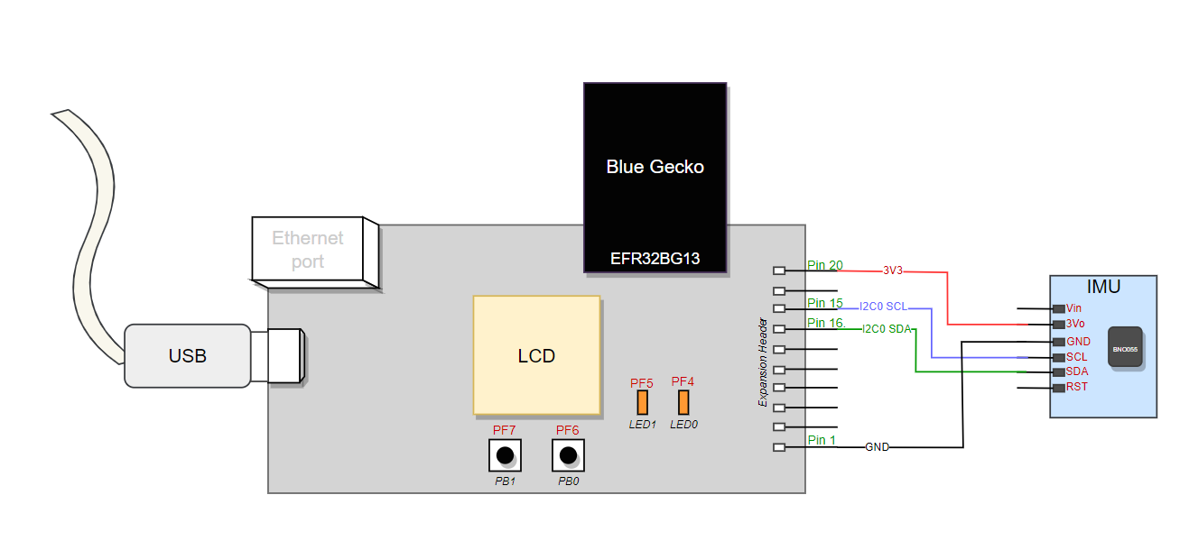

Figure 24 IMU Interface with Blue Gecko

* + - Program was written for I2C_FREQ_STANDARD_MAX which is 92KHz data transfer.
    - Digilent’s Analog Discovery 2 logic analyzer was used to monitor the I2C transaction
    - Hardware Interface and Logic analyzer trace is shown below.

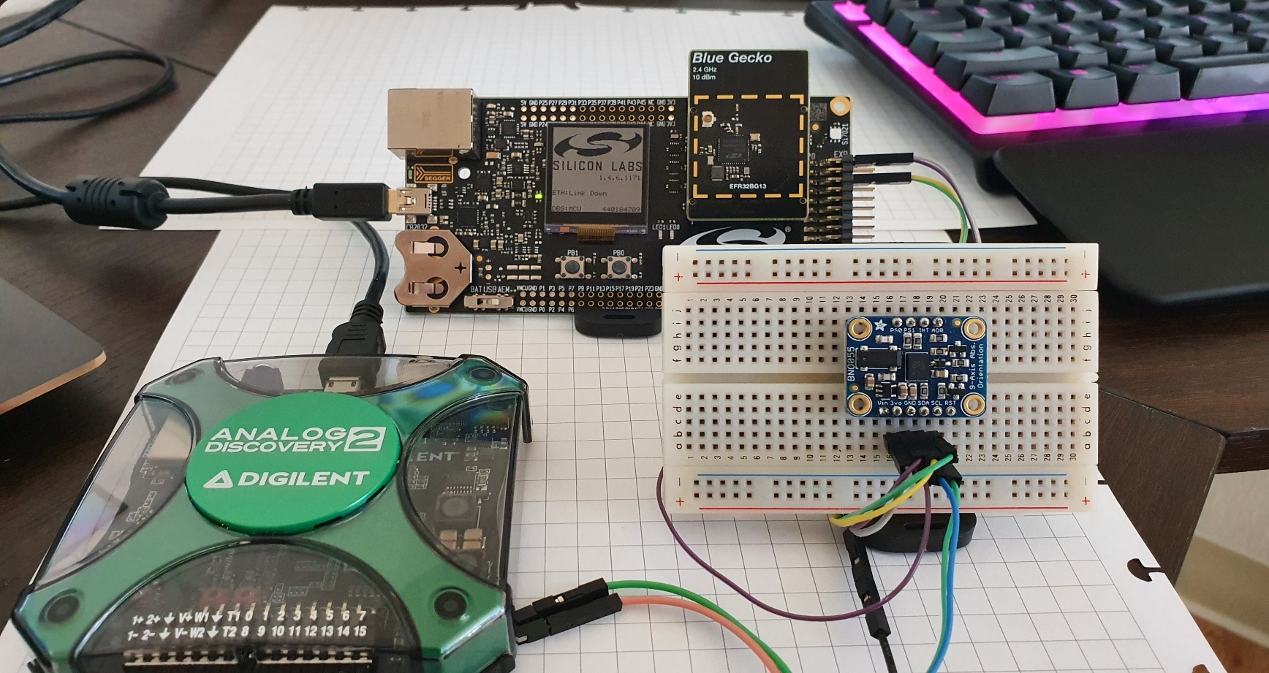

Figure 25 Hardware: IMU with Blue Gecko

* + I2C Transactions
    - Accelerometer (x direction) lower byte data is stored in register 0x08 of BNO055.

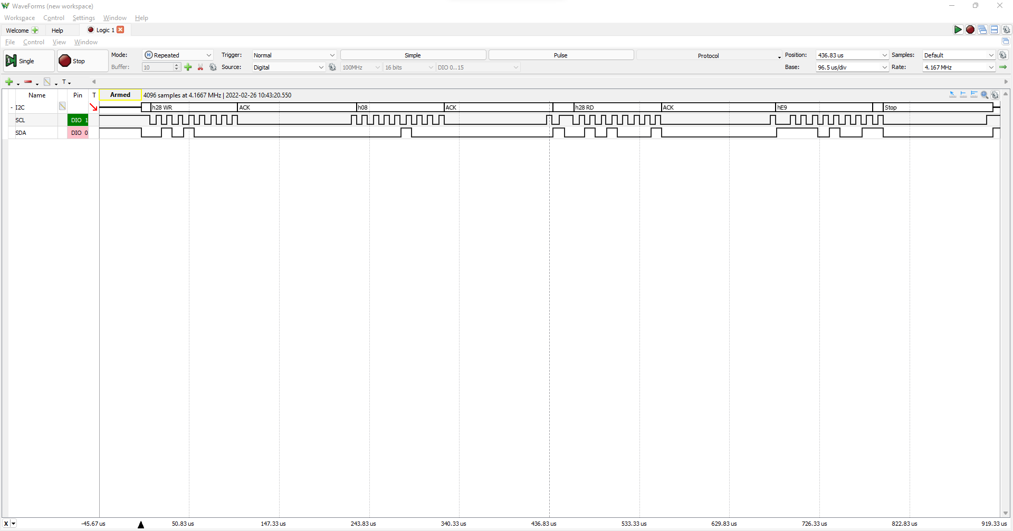

Accelerometer value read 0xE9

Figure 26 Logic Analyzer trace for IMU

* + - Above activity was performed with different accelerations to verify change in values in register 0x08.
    - Next task for IMU would be writing down a wrapper functionality to receive
      * Angle using IMU fusion
      * Compass using Magnetometer

### **Magnetic Encoder Bring-up**

* + AS5147P Interfacing with Blue Gecko
    - Magnetic encoder uses Hall effect sensor AS5147 to detect change in magnetic field.
    - It supports SPI, ABI, UVW and PWM interfaces. ABI interface would be appropriate for our application as we can keep microcontroller in lowest possible energy mode whenever there’s no activity.
  + Connection diagram

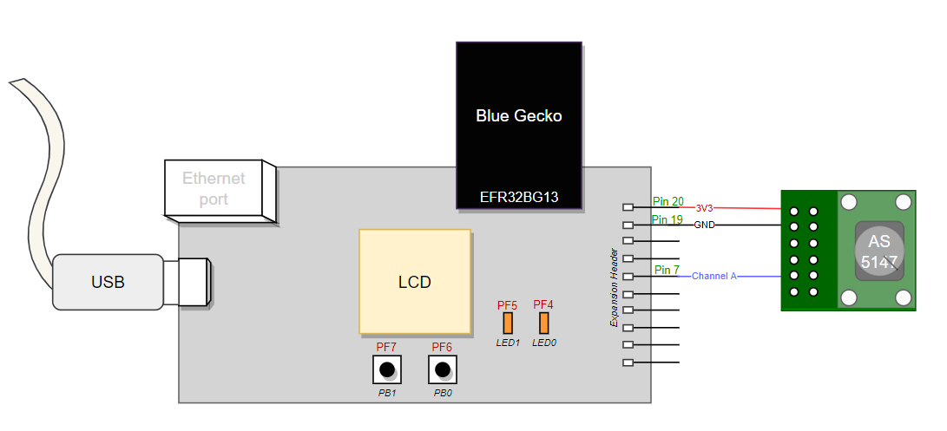

Figure 27 Magnetic Encoder Interface with Blue Gecko

* + - Program was written to receive interrupts on GPIO pin and keep the count of pulses for channel A of Magnetic encoder. This count was printed over serial terminal.
    - Energy profiler was used to see variation in energy consumption as pulses were received.
    - With current configuration 1024 pulses are received per revolution.
    - It is configurable over SPI to receive 256 pulses per revolution
    - Hardware Interface and Energy profiler shown below

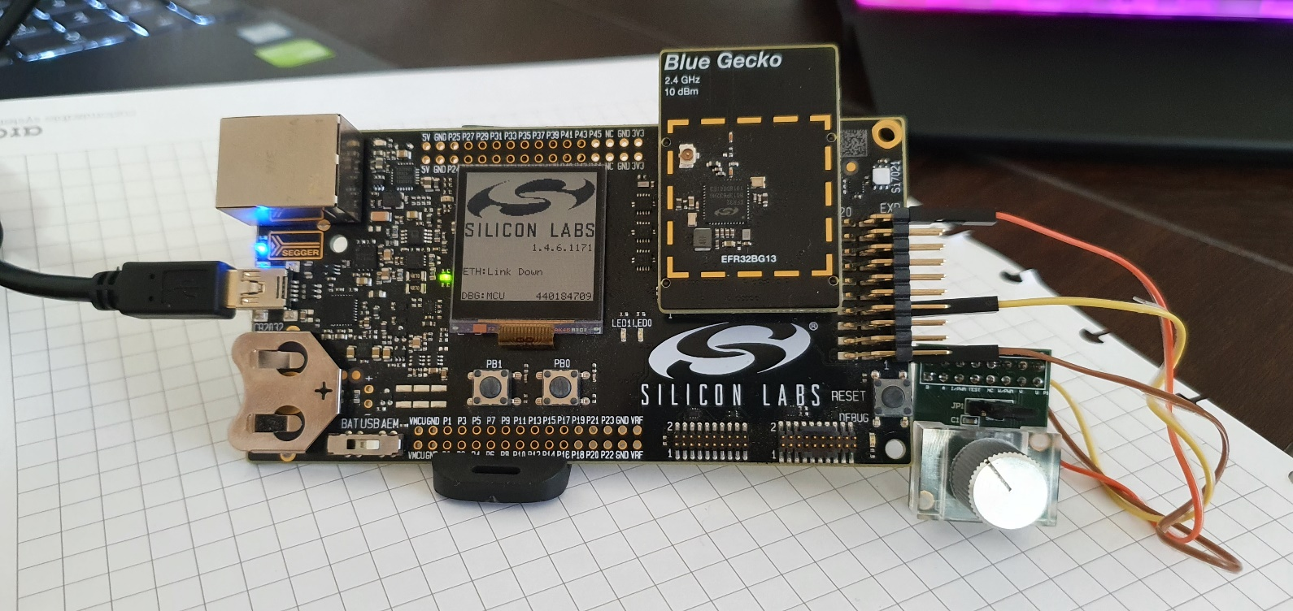

Figure 28 Hardware: Magnetic Encoder with Blue Gecko

* + Energy profiler and Serial log
    - Energy profiler showed typical current Magnetic encoder is consuming which is around 900uA.  
      Note: This measurement is only for 1 channel.
    - Program was setting EFR32 radio board in EM2 energy mode where Bluetooth is operational

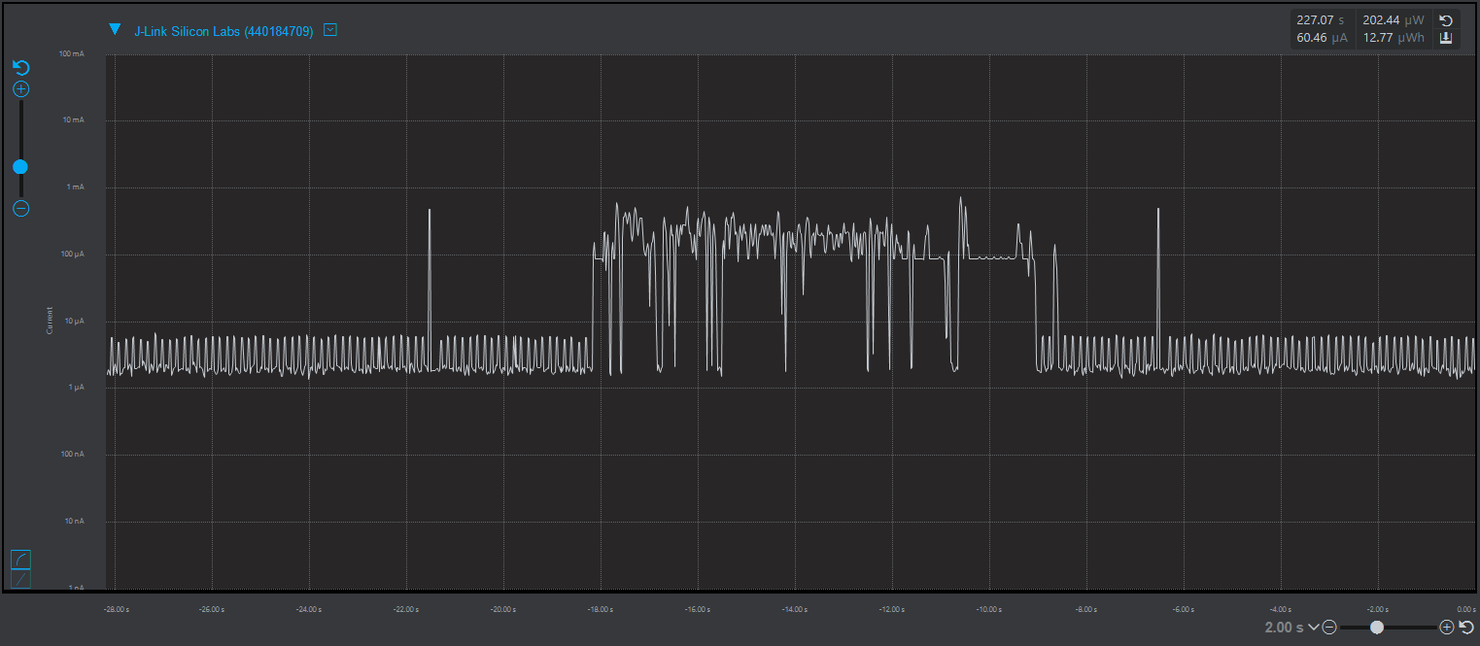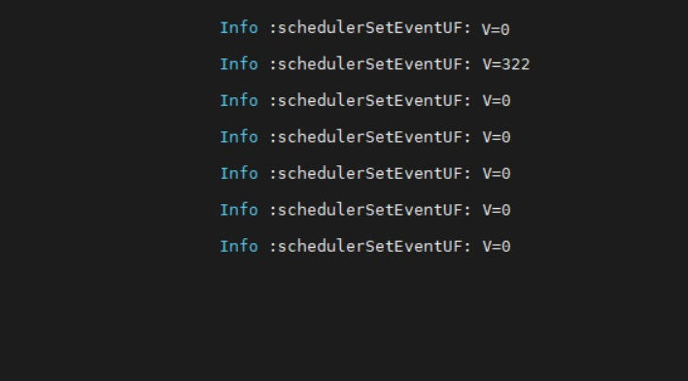

Energy profiler for pulses received

Serial Terminal

Log

Figure 29 Energy profile and Serial log for Magnetic Encoder

* + - Challenges for magnetic encoder:
      * It’s been observed that EFR32 for above operation is not able to handle 1024 pulses per revolution when wheel rotates faster. In fact, this much resolution is not required for this application.
      * In order to resolve this, plan is to use low power frequency divider to reduce pulses. Required number of pulses per revolution to maintain stated measurement resolution can be calculated as follows

Assumption: Wheel diameter = 3cm

Circumference of wheel = $π*d=9.42 cm$

In order to maintain minimum resolution of 0.5cm, around 20 pulses are required per resolution.

Magnetic encoder can be operated in 256 ppr mode with configuration bits and this further can be divided by 8 using external frequency divider. This would result in 32 pulses per revolution.

### **Actual Bulk capacitor value required (considering the DC bias)**

* + As per our bulk capacitor calculations, Cubit board requires 100uF capacitor.
  + In order to find out equivalent capacitance that would give 100uF, simsurfing tool from murata was used.  
    [SimSurfing: Multilayer Ceramic Capacitors - Murata Manufacturing](https://ds.murata.co.jp/simsurfing/mlcc.html?lcid=en-us&jis=false&md5=5f242d800992593fcc24f15a095886ca)
  + 220uF ([GRM32ER60J227ME05L Murata Electronics | Capacitors | DigiKey](https://www.digikey.com/en/products/detail/murata-electronics/GRM32ER60J227ME05L/7363052)) was selected based on following DC bias characteristic.
    - 3.2v is our operational voltage for the entire circuit
    - Effective bulk capacitor value @ 3.2v = 220 – 52.6% = 104.28uF

Figure 30 DC bias characteristics for bulk capacitor

### **IO Ports in design**

* Buttons
  + - Menu selection switches
* Switches
  + - Operation Mode switch

|  |  |
| --- | --- |
| **Modes** | **Description** |
| All OFF | External supply to PMIC would be disconnected |
| Partial ON | Only PMIC, EFR32 radio board and LCD would be Turned ON |
| All ON | All components and required sensors would be turned ON |

* USB
  + To be used for fast charging of battery where energy from energy source would not be available.
* Battery connector
  + To be used for External Lipo battery

For above mentioned IO ports ESD protection would be required.

### **ESD protection**

|  |  |
| --- | --- |
| **IO Ports** | **ESD part** |
| HMI pushbutton switches (4) | SP1001-04JTG |
| USB | SP1003 |
| Battery Connector | SP1003 |

* SP1003 part used for VBUS pin from USB connector and power pin from battery connector has clamping voltage of 12V which is closer to maximum allowable input voltage (5V) for PMIC BQ25570. Moreover, this part has low leakage current of 100nA (MAX) at 5V operation.
* SP1001 part used for ESD protection on push button switches satisfies the requirement of 4 I/O pins connection for 4 push-button switches.

## Activities planned for the upcoming week:

* Incorporate changes in board schematic suggested in the review
* Designing a layout for the final board
* Interface ultrasonic sensor with Blue Gecko development board.

1. IMU datasheet: [BNO055 Datasheet (mouser.com)](https://www.mouser.com/datasheet/2/783/BST_BNO055_DS000-1509603.pdf)

   Blue Gecko datasheet[: EFR32BG13 Data Sheet: Blue Gecko Bluetooth® Low Energy SoC Family (silabs.com)](https://www.silabs.com/documents/public/data-sheets/efr32bg13-datasheet.pdf)

   Magnetic Rotary Encoder datasheet[: AS5147P-TS_EK_AB ams | Development Boards, Kits, Programmers | DigiKey](https://www.digikey.com/en/products/detail/ams/AS5147P-TS-EK-AB/5452349) LCD Display datasheet[: Data+sheet.pdf (adafruit.com)](https://cdn-shop.adafruit.com/product-files/3502/Data+sheet.pdf) 
2. [EETimes - Buck-boost vs. buck converter: it's about battery life in portables](https://www.eetimes.com/buck-boost-vs-buck-converter-its-about-battery-life-in-portables/) 
3. TPS62840 datasheet[: TPS62840 1.8-V to 6.5-V, 750-mA, 60-nA IQ Step-Down Converter datasheet (Rev. D)](https://www.ti.com/lit/ds/symlink/tps62840.pdf?HQS=dis-dk-null-digikeymode-dsf-pf-null-wwe&ts=1644076764086&ref_url=https%253A%252F%252Fwww.ti.com%252Fgeneral%252Fdocs%252Fsuppproductinfo.tsp%253FdistId%253D10%2526gotoUrl%253Dhttps%253A%252F%252Fwww.ti.com%252Flit%252Fgpn%252Ftps62840)

   [(ti.com)](https://www.ti.com/lit/ds/symlink/tps62840.pdf?HQS=dis-dk-null-digikeymode-dsf-pf-null-wwe&ts=1644076764086&ref_url=https%253A%252F%252Fwww.ti.com%252Fgeneral%252Fdocs%252Fsuppproductinfo.tsp%253FdistId%253D10%2526gotoUrl%253Dhttps%253A%252F%252Fwww.ti.com%252Flit%252Fgpn%252Ftps62840) 
4. BQ25570 internal buck converter vs external TPS62840 buck converter: The TPS62840 buck converter has higher efficiency at low current consumption than the internal buck converter.